For treatment recommendation we want dataset that include : Patient state, diagnosis/condition, treatment actually given, and outcome after treatment.
1. MIMIC-IV :
Medical Information Mart for Intensive Care IV with over 65,000 ICU patients and over 200,000 emergency-department patients.
It contains:
- ICU patient vitals (high-frequency), Lab tests, Diagnoses (ICD codes), Medications + procedures, Outcomes (mortality, discharge)
- Link : https://physionet.org/content/mimiciv/3.1
Beth Israel Deaconess Medical Center (Boston, USA). It comprises three main subsets: hosp (overall hospital information), icu (intensive care unit stays, vital signs, interventions), and notes. MIMIC-IV succeeds MIMIC-III, offering a reorganized relational structure.
Access requires successful completion of training on the protection of human subjects and signing a user agreement via the PhysioNet platform.
2. eICU Collaborative Research Database
- Multi-hospital variation (better generalization)
- Link : https://physionet.org/content/eicu-crd/2.0/
It covers over 200,000 ICU admissions from 208 hospitals and includes vitals, care plans, severity scores, diagnosis information, and treatment details
Pair eICU with MIMIC-IV for more rich and generalized data .
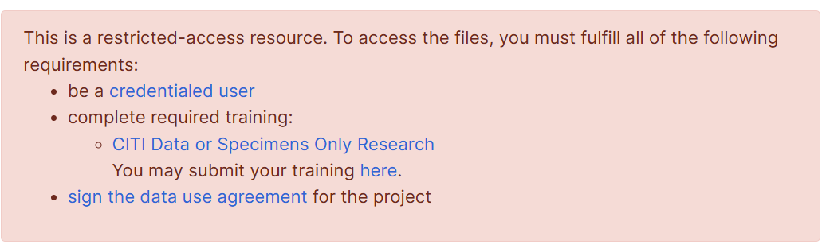
3. Zenodo: Prostate cancer clinical, pathological, and follow-up dataset
Zenodo dataset contains 600 prostate cancer patients with demographics, diagnosis details, treatment type, treatment dates, radiation doses, hormone therapy details, follow-up PSA, recurrence, metastasis, and survival status .
Link : https://zenodo.org/records/15007105
why is it useful
- diagnosis
- treatment choice
- follow-up outcomes
- recurrence and survival signals
Main limitation:
- single disease
- moderate sample size
- Specific Not general
4. GitHub: PEACE dataset
PEACE is a cancer pain pharmaceutical-care dataset with records for over 38,000 patients. The repository describes demographics, clinical examination, medication plans, treatment outcomes, and patient self-perceptions, with multiple follow-ups. It include sustained outcome information.
Link : https://github.com/YTYTYD/PEACE
Why it is useful:
- medication decision focus
- outcomes and follow-up
- patient-reported effects included
Main limitation:
- narrow clinical scope
- Specific not General Treatment

5. Kaggle: Patient Clinical & Treatment Data
It describes disease diagnosis, genetic risks, treatment types, hospital stay details, and post-treatment outcomes.
Link : https://www.kaggle.com/datasets/taruneshburman/patient-clinical-and-treatment-data
Main limitation:
- Kaggle datasets often lack the governance, provenance, and clinical rigor of PhysioNet or formally published clinical repositories
- Requires verification whether it is real, synthetic, or partially simulated before using it in a paper
To prototype the end-to-end conversational and explainability system we can use synthetic datasets then switch to real data later .
Below are some synthetic but calibrated to real statistics and directly usable for our use case.
- Patient Records 100K patients · 15 conditions
  - Link: https://www.kaggle.com/datasets/sergionefedov/patient-records-100k-patients-15-conditions
  - It's a comprehensive synthetic US adult EHR dataset (2018–2024) with ~100,000 patients across 15 common conditions (e.g., hypertension, diabetes, COPD—using ICD-10 codes). It includes:
    - Patient info: Demographics, vitals, BMI, lifestyle, comorbidities, insurance .
    - Diagnoses: Visit-level ICD-10 records .
    - Treatments: Medications/prescriptions with dose, frequency, and adherence.
    - Outcomes: Lab results , hospitalization outcomes .
  - Size: Multiple CSV files; fully structured for ML (e.g., survival analysis, readmission prediction, treatment effectiveness).
  - License/Usability: Apache 2.0; high usability for clinical ML tasks.
  - Suitability: Ideal for building treatment recommendation models e.g., predict optimal medication based on diagnosis + labs + patient profile, then evaluate against observed outcomes. Synthetic but based on CDC/NHANES/CMS real benchmarks.
- richardyoung/synthea-575k-patients
- Link: https://huggingface.co/datasets/richardyoung/synthea-575k-patients
- Why it fits: Massive synthetic EHR dataset generated with Synthea (gold-standard open-source patient simulator). Covers 575,415 patients with complete longitudinal medical histories. Includes conditions/diagnoses, medications, encounters, observations (labs/vitals), procedures, and simulated outcomes (via realistic disease progression and treatment responses).
- Suitability: Synthea explicitly models patient journeys with treatments and outcomes. Use for training on full histories (e.g., sequence-based recommenders). Excellent for large-scale sequence modeling, patient trajectory modeling, recommendation over longitudinal histories, architecture testing.

